[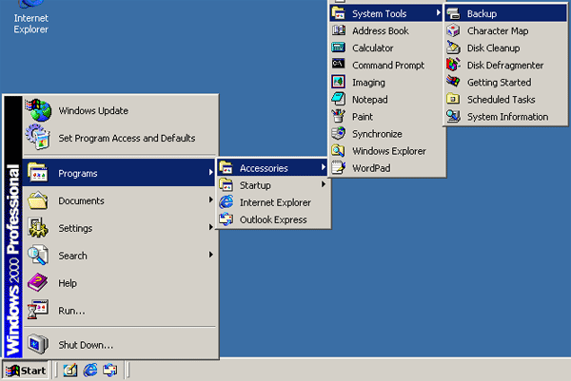](http://www.google.com.eg/url?sa=i&source=images&cd=&cad=rja&docid=yf9xF6kw93DnqM&tbnid=hjonoA6iuMQW_M:&ved=0CAgQjRwwAA&url=https%3A%2F%2Fsupport.kaspersky.com%2Fkis7%2Ftech%3Fqid%3D208279080&ei=-lwwUsHFCYah0wXeuoCoBA&psig=AFQjCNEs_r9Rs9abw8-1A5D6Esr26Xhnng&ust=1378987642227089)The Thinker!   
  
Can you help The Thinker to arrange the different operating systems into the correct category? Move the images next to the correct name in The Thinker’s head.

[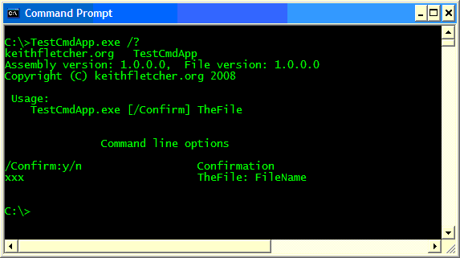](http://www.google.com.eg/url?sa=i&rct=j&q=&esrc=s&frm=1&source=images&cd=&cad=rja&docid=3tIsrke1Trn6cM&tbnid=rsZdK_wcM1Q9pM:&ved=0CAUQjRw&url=http%3A%2F%2Fwww.codeproject.com%2FArticles%2F28997%2FC-command-line-parsing&ei=c14wUuGUIoKl0QWGvYCgBA&psig=AFQjCNHXjXGwAYbENLF6nvZSn4Ydngb-BQ&ust=1378987991360676)[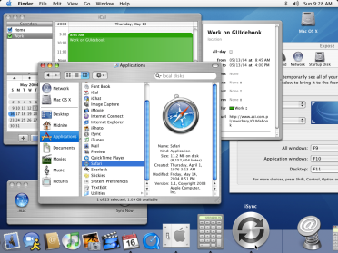](http://www.google.com.eg/url?sa=i&rct=j&q=&esrc=s&frm=1&source=images&cd=&cad=rja&docid=82KWfszjDJGkbM&tbnid=7kK1ytg06wJpvM:&ved=0CAUQjRw&url=http%3A%2F%2Fwww.guidebookgallery.org%2Fscreenshots%2Fmacosx103&ei=CF4wUsaEFKqm0wW0xYCIAw&psig=AFQjCNEQobnoOc_AurIUFcqRUao3FmeZAQ&ust=1378987903995227)

**[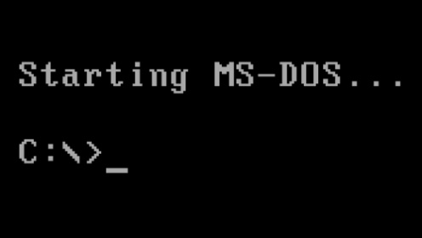](http://www.google.com.eg/url?sa=i&rct=j&q=&esrc=s&frm=1&source=images&cd=&cad=rja&docid=8nXo4dKpuHJxTM&tbnid=W64qDkavgAO2DM:&ved=0CAUQjRw&url=http%3A%2F%2Fwww.extremetech.com%2Fcomputing%2F91202-ms-dos-is-30-years-old-today&ei=sF4wUq3uLISp0QWfhoDICw&psig=AFQjCNEFC0pRoczGqFGG2OGOoXjM_LugTg&ust=1378988069962081)[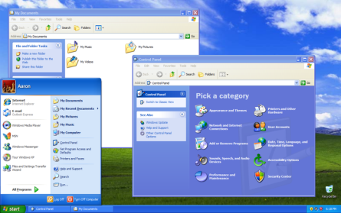](http://www.google.com.eg/url?sa=i&rct=j&q=&esrc=s&frm=1&source=images&cd=&cad=rja&docid=LHzwSc6B84vgPM&tbnid=OZJCalfUv-GSzM:&ved=0CAUQjRw&url=http%3A%2F%2Fen.wikipedia.org%2Fwiki%2FFile%3AWindows_XP_SP3.png&ei=iV0wUr-eJYmZ0QXFvYHADA&psig=AFQjCNE5olFgW1UakqOVNde2sZV9T_LoUA&ust=1378987777284750)**

**[](http://www.google.com.eg/url?sa=i&rct=j&q=&esrc=s&frm=1&source=images&cd=&cad=rja&docid=fH9TAKl4NKCzpM&tbnid=9yrCaz7lXpVUMM:&ved=0CAUQjRw&url=http%3A%2F%2Fliveabundantly.ca%2Fyoure-allowed-to-change-your-mind%2F&ei=vV8wUtjiN4Wl0QXOsIEw&psig=AFQjCNGTBXiAbNHJLrtSCl1W4m77PidnCw&ust=1378988300360371)**

These are GUI operating systems

These are command line operating systems

