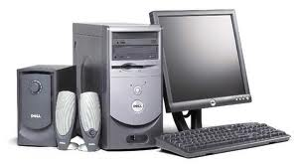The Thinker!   
  
Can you help The Thinker to arrange the Computers with their correct name? Move the images next to the name in The Thinker’s head.

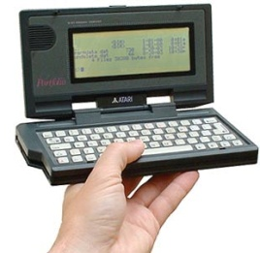

This is a Palmtop

This is a Mainframe

This is a Notebook

This is a Laptop



This is a PDA

This is a Desktop PC



