Different Types of Computers
Task 1
Arrange the arrows so they provide a link between the correct names for the different types of computers.
Mainframe  Personal Digital Assistant  Palmtop  Laptop  Desktop PC  Notebook | 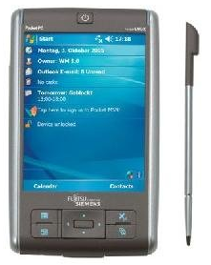  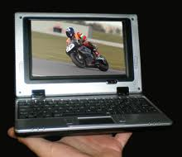  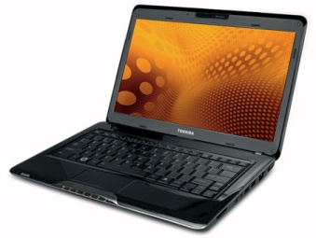  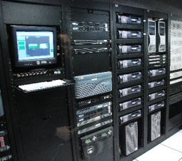  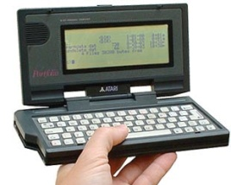  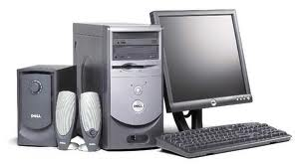
Task 2
In the table below you should describe, in as much detail as you can, the characteristics of each type of computer.
Use the course website and notes to help you to do this but make sure that what you enter into the boxes is in your own words.
Computer  Type | Description and Advantages/Disadvantages (3 of each)
Desktop PC | Description:  Advantages:  Disadvantages:
Mainframe | Description:  Advantages:  Disadvantages:
Personal Digital Assistant | Description:  Advantages:  Disadvantages:
Laptop | Description:  Advantages:  Disadvantages:
Notebook | Description:  Advantages:  Disadvantages:

